Project Initialization and Planning Phase

|  |  |
| --- | --- |
| Date | 15 November 2024 |
| Team ID | 739909 |
| Project Name | Unlocking the Minds: Analyzing Mental Health with NLP |
| Maximum Marks | 3 Marks |

**Define Problem Statements (Customer Problem Statement Template):**

Mental health is a complex and multifaceted issue, often burdened by stigma, making it challenging to understand and address. Traditional methods of analyzing mental health data are limited in scope and may not capture the nuanced linguistic patterns present in textual data. This project aims to leverage Natural Language Processing (NLP) techniques to analyze diverse sources of textual data—such as social media, therapy session transcripts, and academic research—to extract valuable insights into mental health conditions. The goal is to deepen understanding of mental health, inform research and clinical practices, support advocacy efforts, and ultimately contribute to more effective interventions and support systems.

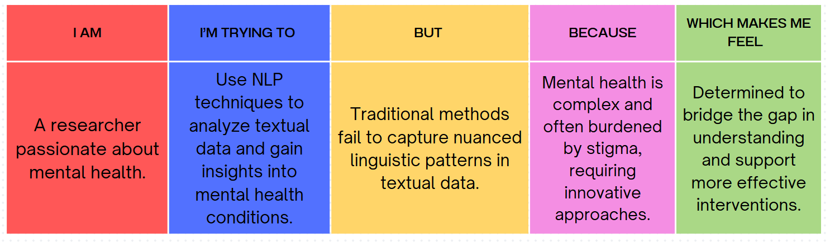

|  |  |  |  |  |  |
| --- | --- | --- | --- | --- | --- |
| **Problem Statement**  **(PS)** | **I am**  **(Customer)** | **I’m trying to** | **But** | **Because** | **Which makes me feel** |
| PS-1 | A researcher passionate about mental health. | Use NLP techniques to analyze textual data and gain insights into mental health conditions. | Traditional methods fail to capture nuanced linguistic patterns in textual data. | Mental health is complex and often burdened by stigma, requiring innovative approaches. | Determined to bridge the gap in understanding and support more effective interventions. |